Wireless Projection of Your Laptop in the Science Commons
Koch Center
March 2012

In order to use the technology in the Science Commons, pick up the cabinet keys from the ITS Help Desk.

Open the wooden projector cabinet in front of the stairs by pushing the wooden door slightly. Please hold the door as it opens so that it doesn’t drop freely.

Go to the wooden cabinet under the stairs. Unlock and open the door to reveal the rack of equipment inside.
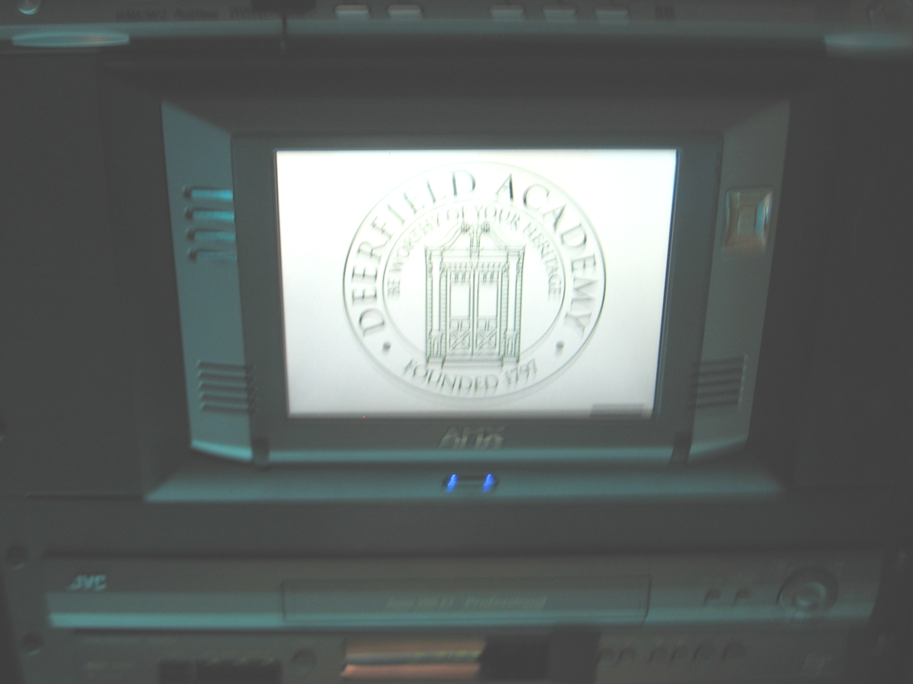
In the middle of the right rack you will see the Touch Panel.

Tap the Touch Panel to wake it up.

You can use the Touch Panel from the rack or you can remove it and use it from anywhere in the room. To remove the Touch Panel, press the blue button beneath the Touch Panel. The Touch Panel will automatically eject from its cradle. Gently lift it from the cradle. There is a stand that mounts to the back of the panel on the left side of the rack near the floor. Attach the stand to the Touch Panel.

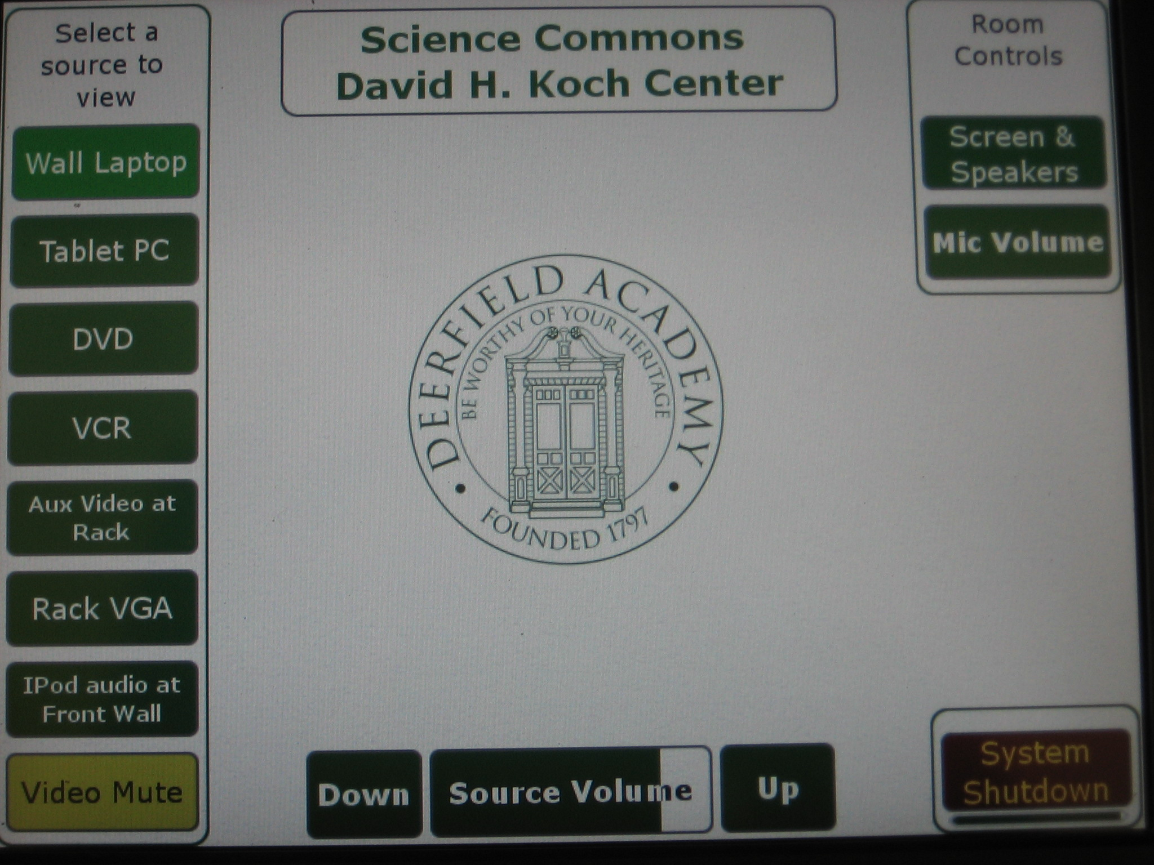

To start the system, press the Tablet PC button on the left side of the Touch Panel. This will lower the screen and speakers and turn on the projector. Audio is not available when using this option.

Once the projector has warmed up, you should see the NEC wireless announcement image. If you do not see the announcement image, check to see if the Tablet PC button on the Touch Panel is light green. If it is not, press the Tablet PC button one more time.

On your MacBook, go to the Application folder on your hard drive. Open the folder Image Express Utility. Double click on the Image Express Utility icon to run the program.

Select the Airport from the Network Ports drop down menu.

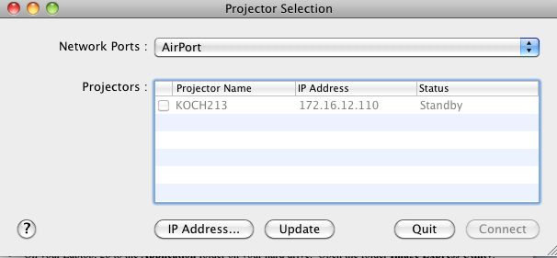

Click on the IP Address… button. Enter the IP Address of the projector to which you will be connecting. IP Addresses are list by room in the DA Wireless Projector spreadsheet. Click OK.

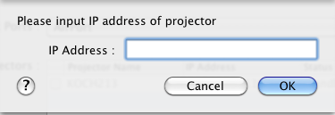

Check the box next to the projector to which you will be connecting and click Connect. Your Laptop image will appear on the projection surface.

To hide the image, press the yellow Video Mute button on the Touch Panel. Press it again to bring the image back.

There is no audio available when using this option. If you need audio, you will need to connect to the projector using VGA and audio cables.

When you are done with your presentation, on the Touch Panel, press the red System Shutdown button in the lower right corner. When prompted:

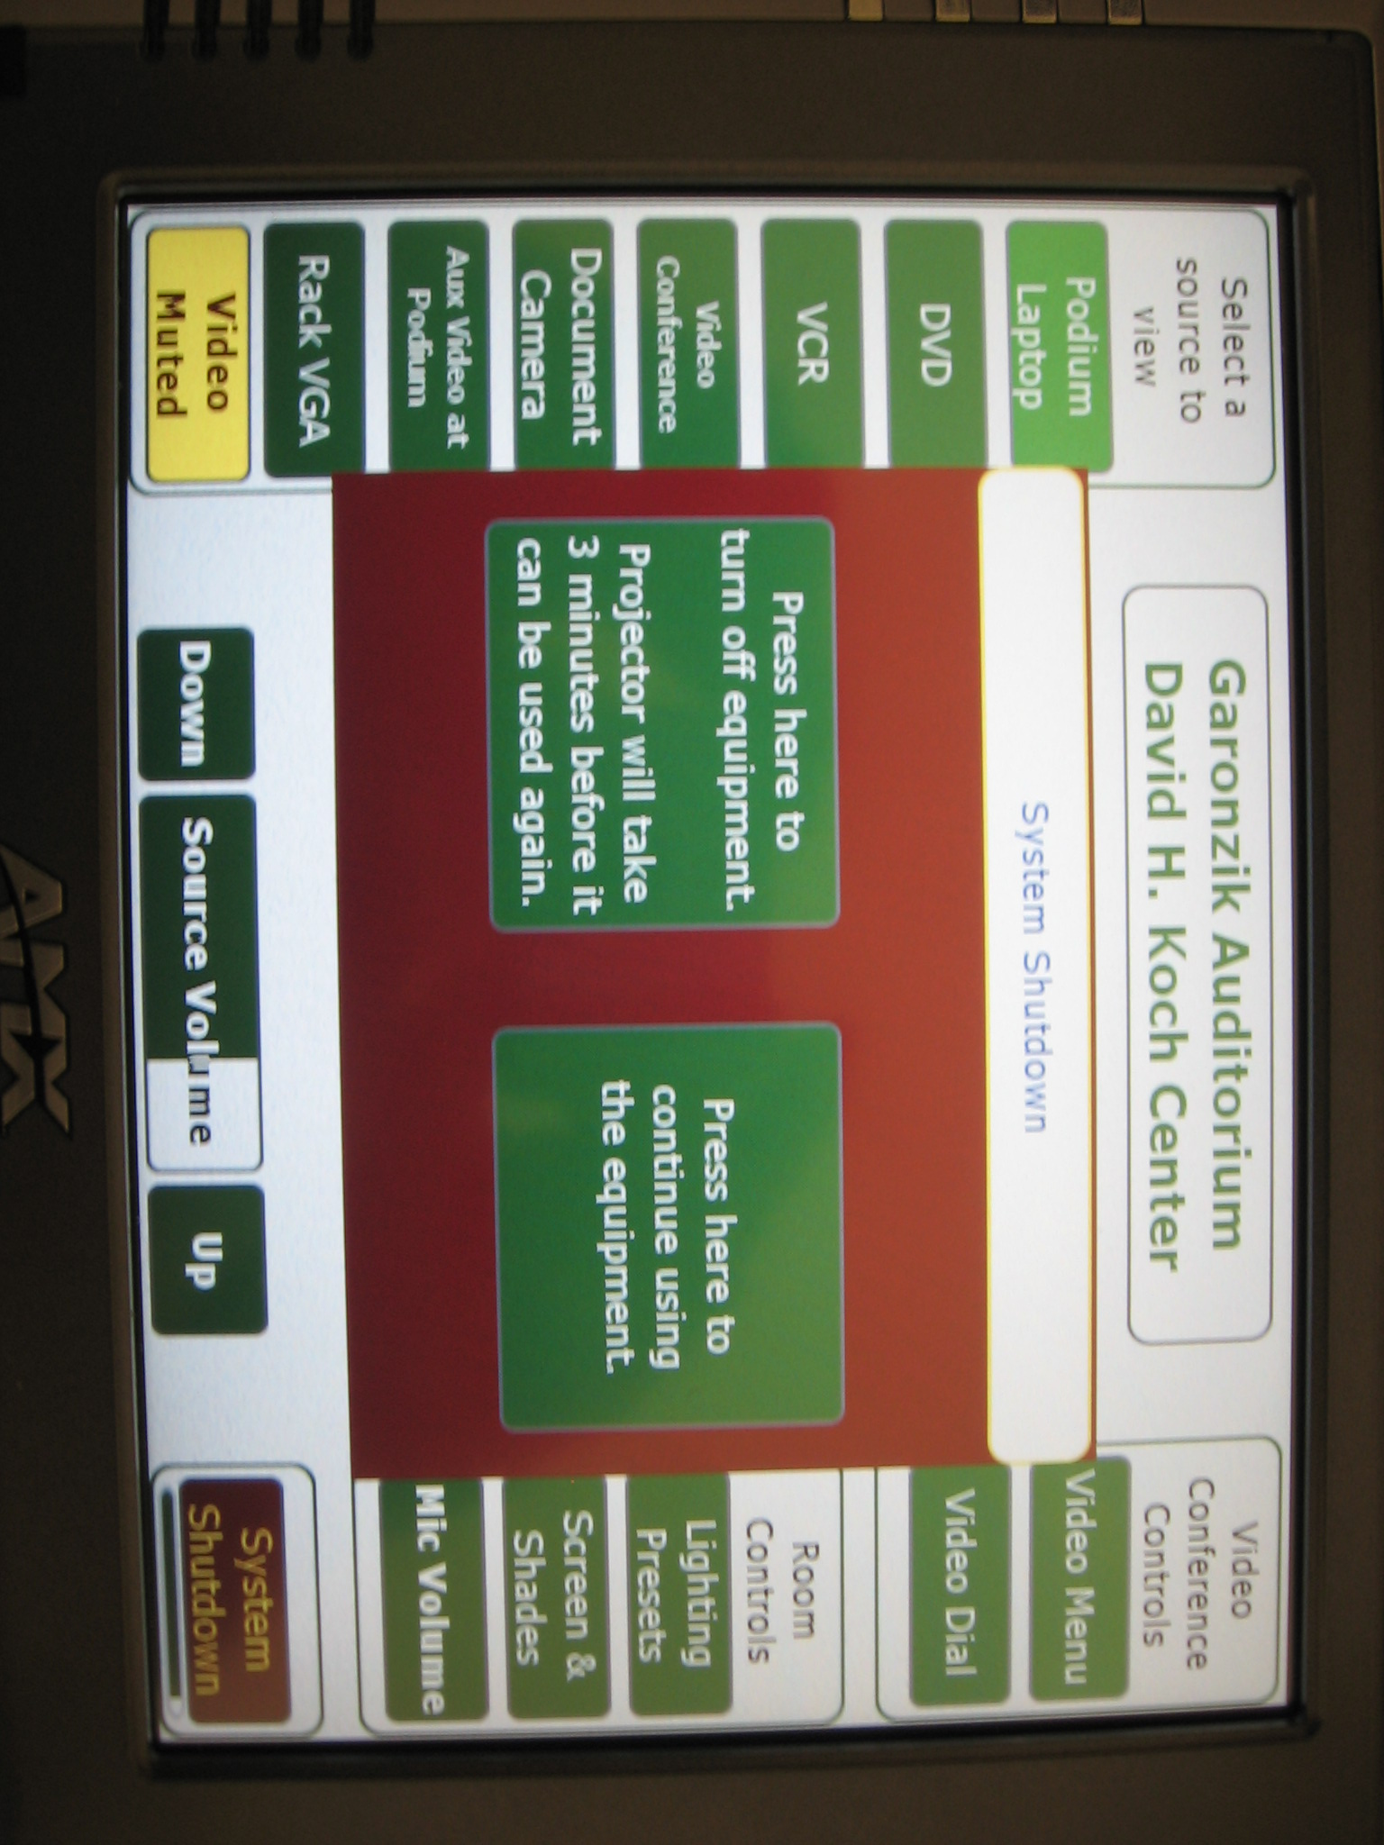

Click on “Press here to turn off equipment.” This will retract the screen and speakers and turn off the projector.

If you have taken the Touch Panel to the podium, remove the stand and replace it on top of the left hand rack. Place the Touch Panel in its rack cradle. Close and lock the cabinet. Return the key to the ITS Help Desk.

If you have any questions, please contact the ITS Help Desk (x1804, helpdesk@deerfield.edu).

