Controlling the Screen & Speakers in the Science Commons
Koch Center
March 2012

When you activate the system to display a laptop, Tablet PC or video, the screen and speakers will automatically lower. However, if you plan to use a different projection device (e.g., slide or film projector) or if you plan to broadcast sound without an image, you will want to be able to lower the screen and speakers separately. This is possible from the AMX Touch Panel.

In order to use the AMX Touch Panel, pick up the cabinet keys from the ITS Help Desk.

Go to the wooden cabinet under the stairs. Unlock and open the door to reveal the rack of equipment inside.

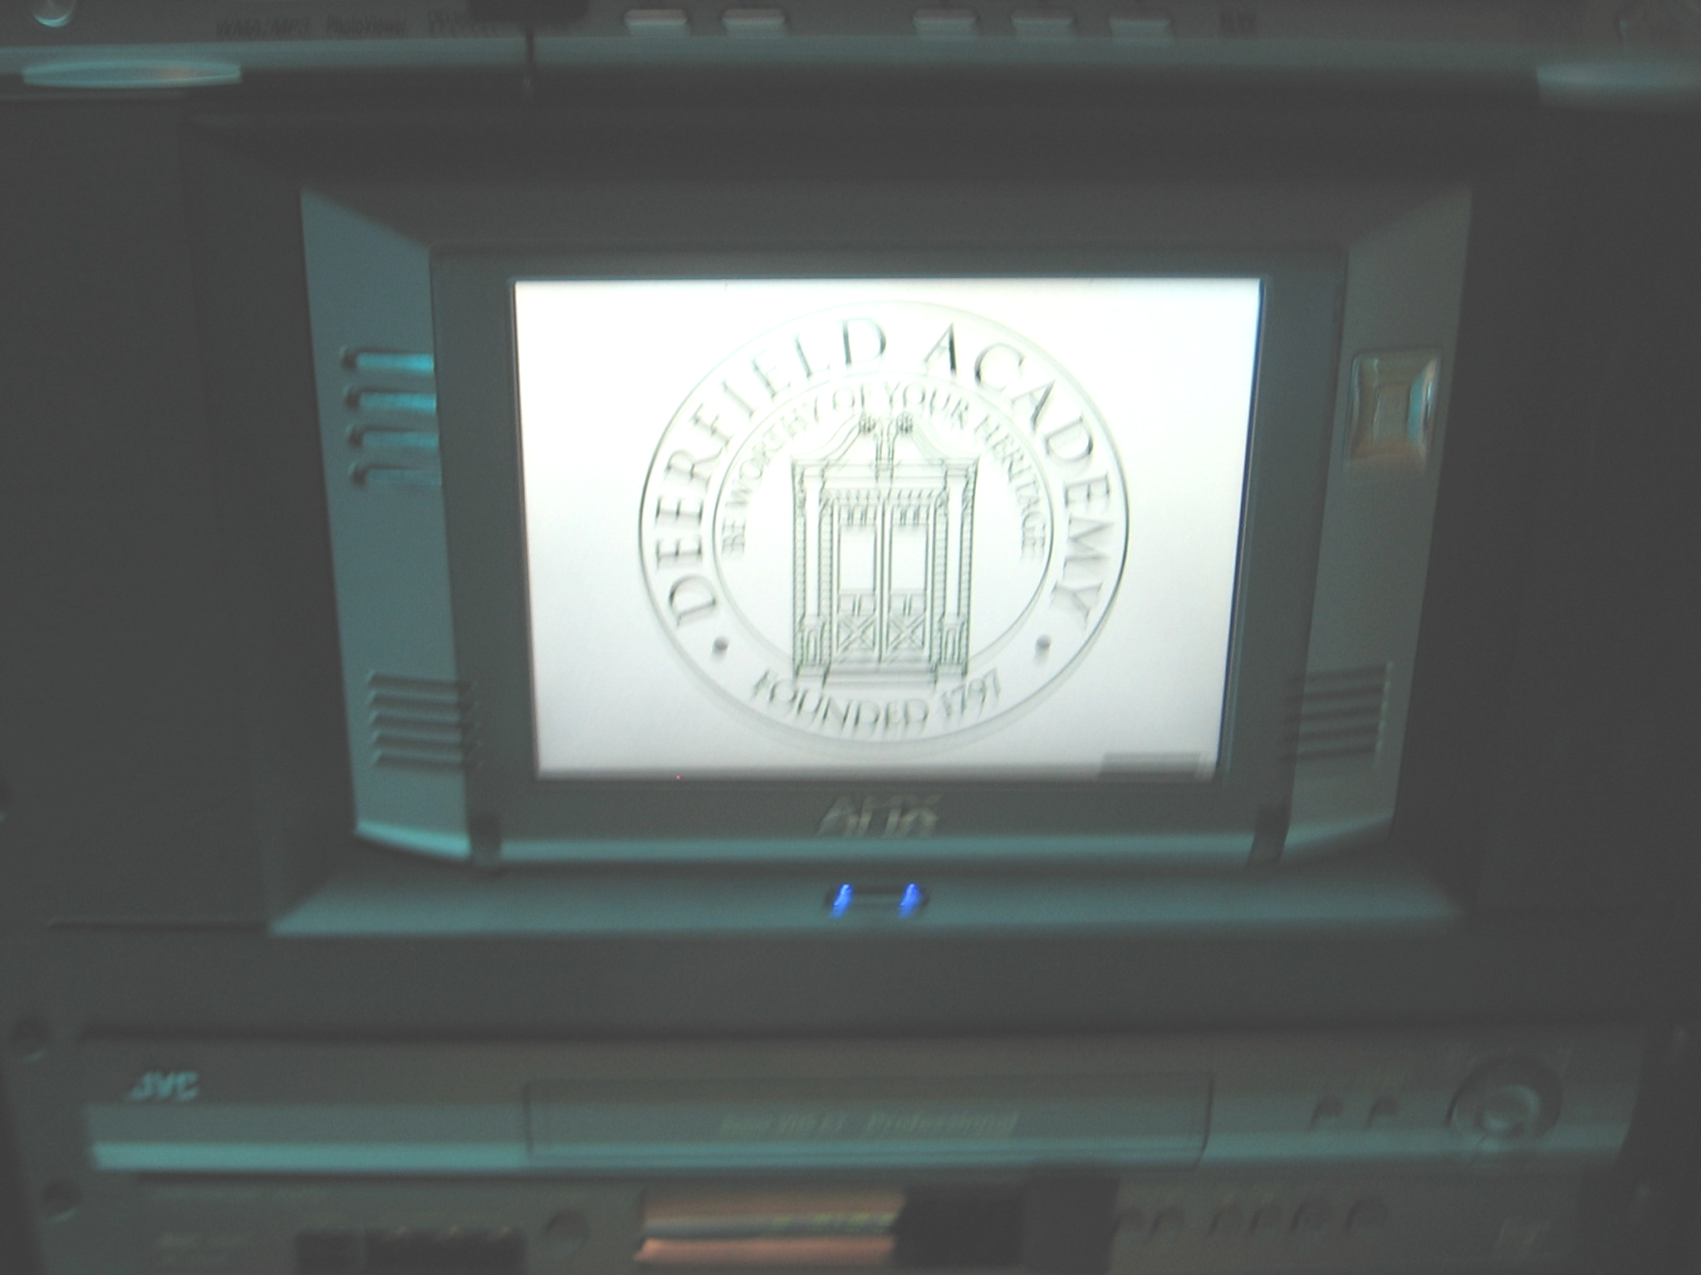
In the middle of the rack you will see the Touch Panel.

Tap the Touch Panel to wake it up.

You can use the Touch Panel from the rack or you can remove it and use it from anywhere in the room. To remove the Touch Panel, press the blue button beneath the Touch Panel. The Touch Panel will automatically eject from its cradle. Gently lift it from the cradle. There is a stand that mounts to the back of the panel on the left side of the rack near the floor. Attach the stand to the Touch Panel.

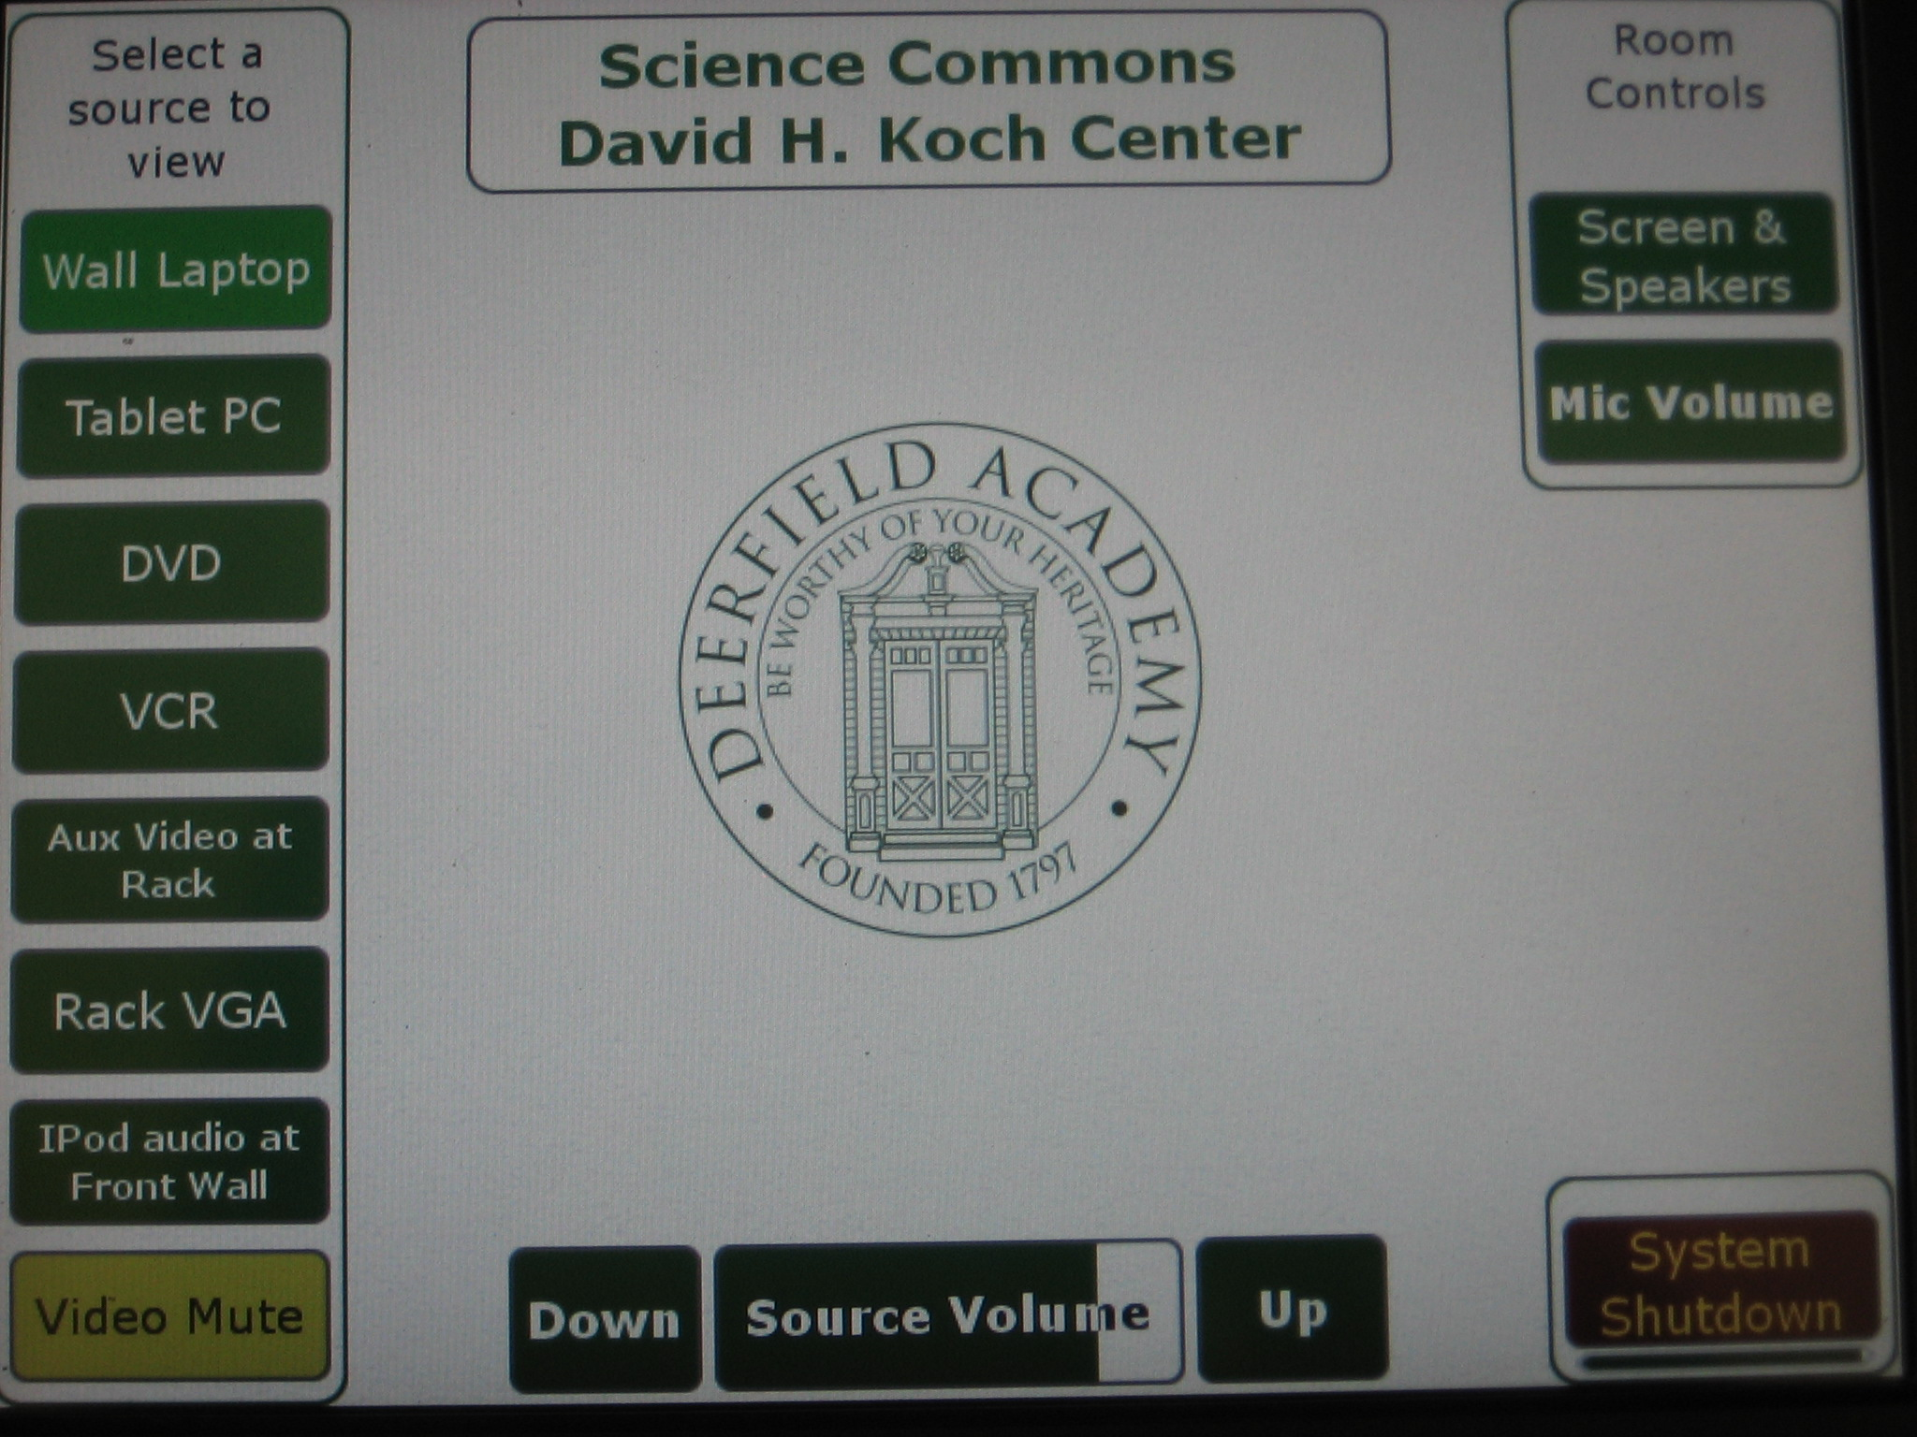

Press the Screen & Speakers button on the right side of the touch panel to
display the Screen and Shades Controls window.

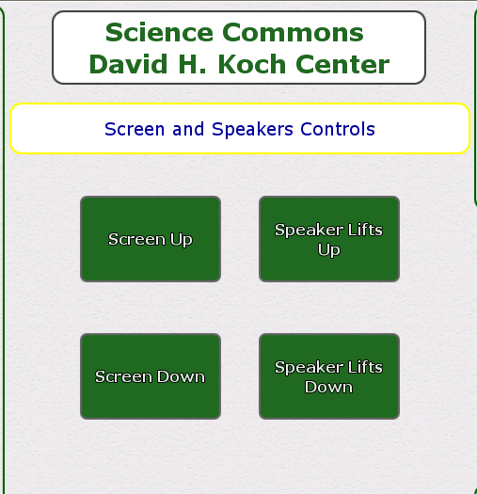

Press

- Screen Up to raise the screen
- Screen Down to lower the screen
- Speaker Lifts Up to raise the shades
- Speaker Lifts Down to lower the shades.

At the end of your presentation, be sure that the screen and speakers are in the UP position. If you have taken the Touch Panel out of the cabinet, remove the stand and replace to the left hand rack near the floor. Place the Touch Panel in its rack cradle. Close and lock the cabinet. Return the key to the ITS Help Desk. Turn Off the lights on your way out of the Auditorium.

If you have any questions, please contact the ITS Help Desk (x1804, helpdesk@deerfield.edu).

