Using the DVD Player in the Science Commons
Koch Center
March 2012

In order to use the technology in the Science Commons, pick up the cabinet keys from the ITS Help Desk.

Open the wooden projector cabinet in front of the stairs by pushing the wooden door slightly. Please hold the door as it opens so that it doesn’t drop freely.

Go to the wooden cabinet under the stairs. Unlock and open the door to reveal the rack of equipment inside.
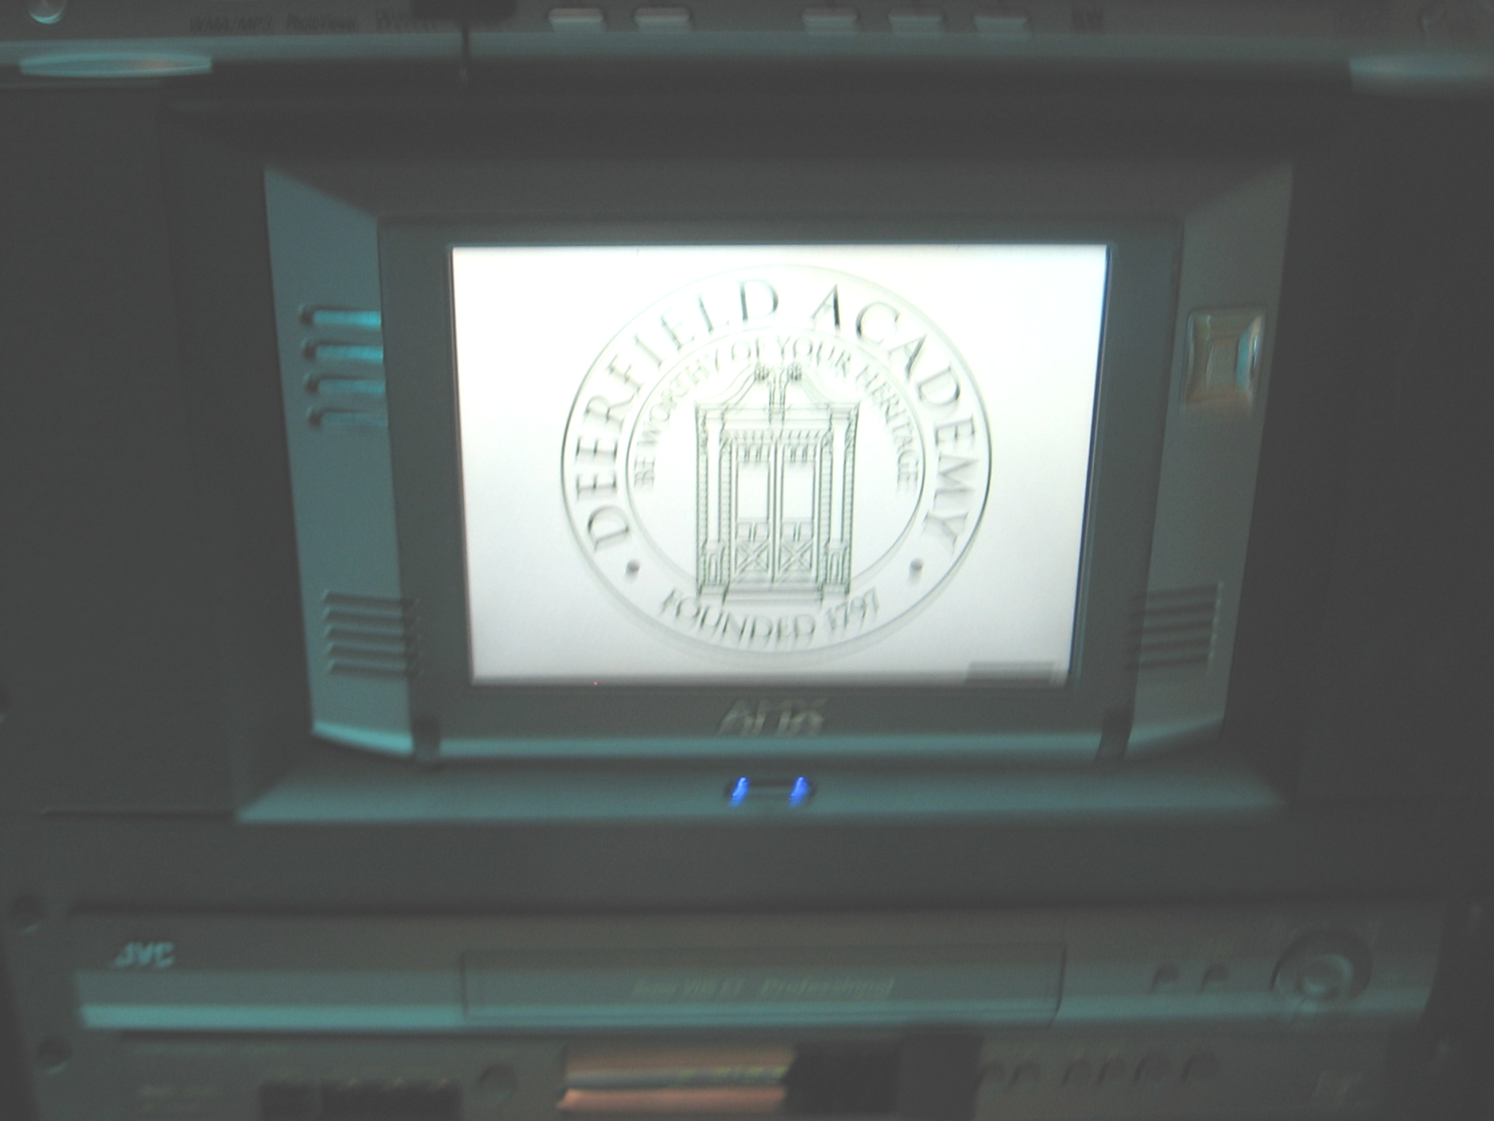

In the middle of the right rack you will see the Touch Panel.

Tap the Touch Panel to wake it up.

You can use the Touch Panel from the rack or you can remove it and use it from anywhere else in the room. To remove the Touch Panel, press the blue button beneath the Touch Panel. The Touch Panel will automatically eject from its cradle. Gently lift it from the cradle. There is a stand that mounts to the back of the panel on top of the left hand rack. Attach the stand to the Touch Panel.

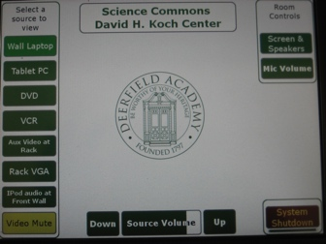

To start the system, press the DVD button on the left side of the Touch Panel. This will lower the screen and speakers and turn on the projector.

While the system is warming up, turn on the DVD player (above the Touch Panel). Insert your DVD.

After the screen has been lowered, you should see the image from the DVD player. If you do not see the image, check to see if the DVD button on the Touch Panel is light green. If it is not, press the DVD button one more time.

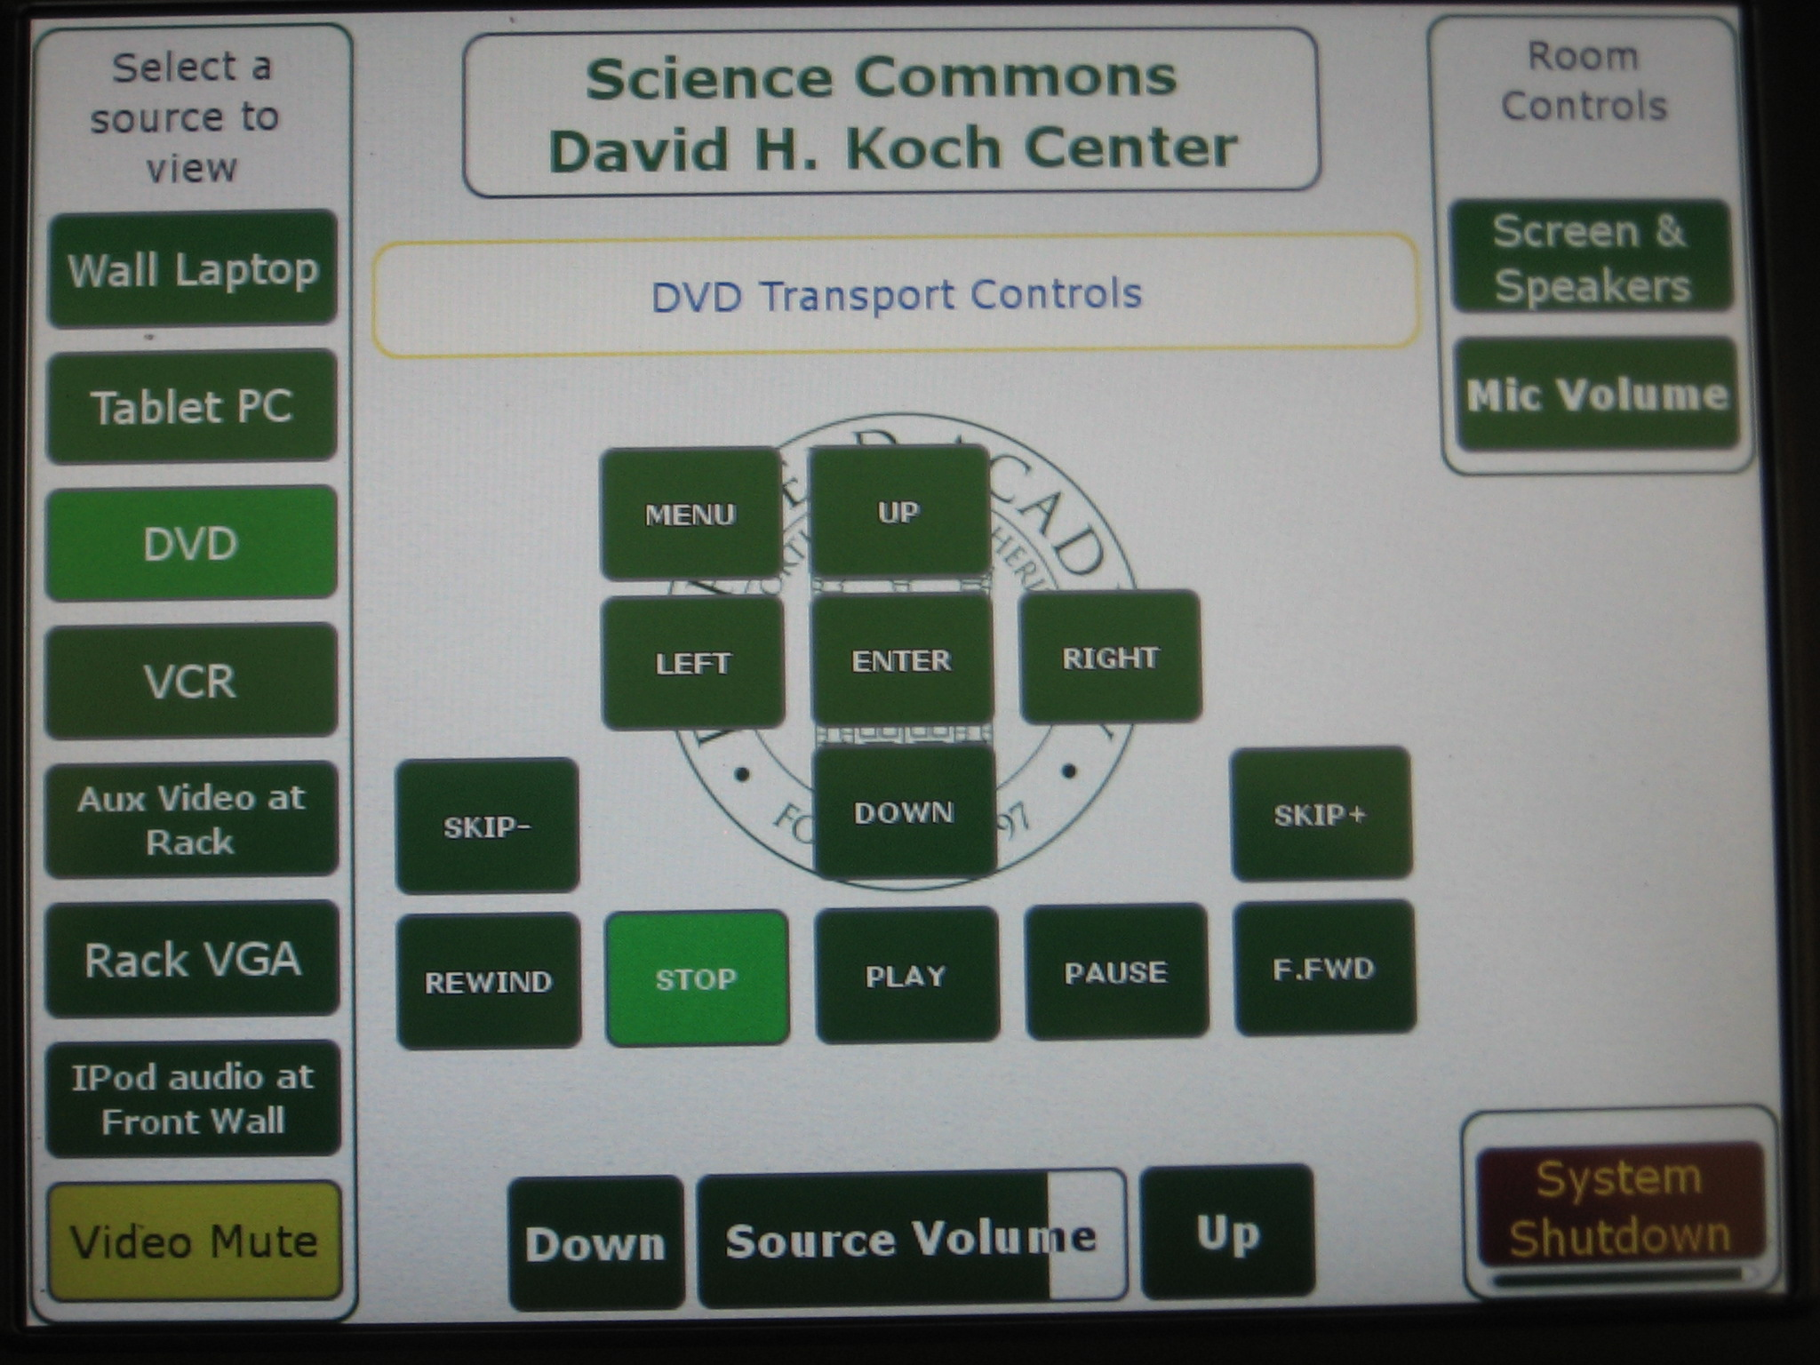

DVD controls can be found on the Touch Panel. To control the volume use the slider buttons at the bottom of the Touch Panel.

To hide the image, press the yellow Video Mute button on the Touch Panel. Press it again to bring the image back.

When you are done, press the red System Shutdown button in the lower right corner of the Touch Panel. When prompted:

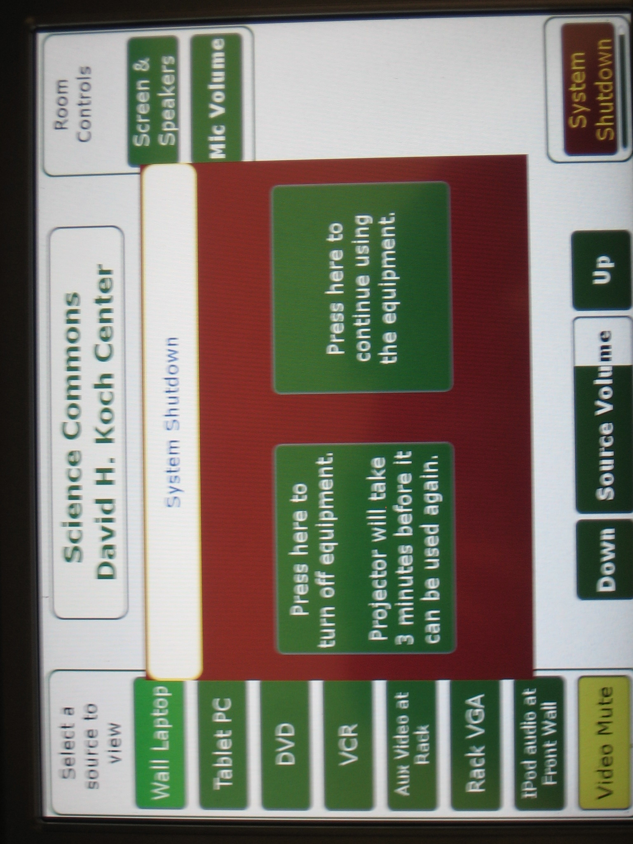

Click on “Press here to turn off equipment.” This will retract the screen and speakers and turn off the projector. Turn off the DVD player.

If necessary, remove the stand and replace to the left side of the rack near the floor. Place the Touch Panel in its rack cradle. Close and lock the cabinet. Close the projector cabinet door. Return the key to the ITS Help Desk.

If you have any questions, please contact the ITS Help Desk (x1804, helpdesk@deerfield.edu).

